**OUTPUT SCREENSHOTS:**

**USER PAGE:**

**ADMIN PAGE:**

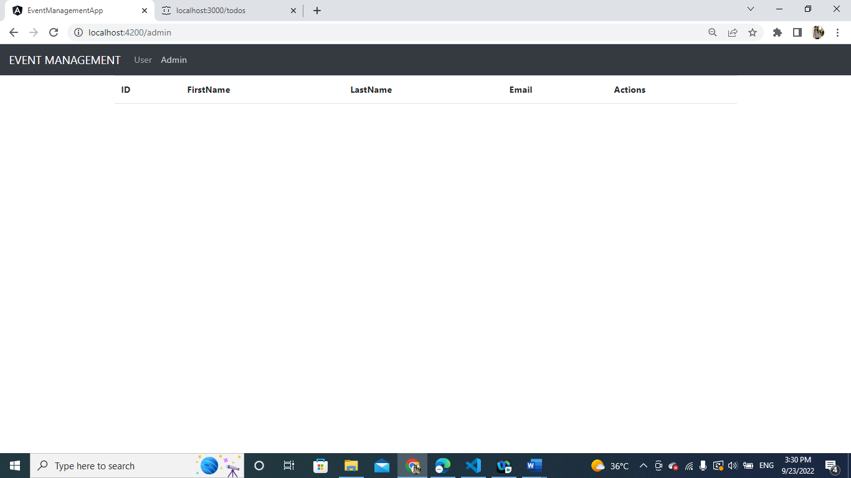

**ADDING USER DETAIL:**

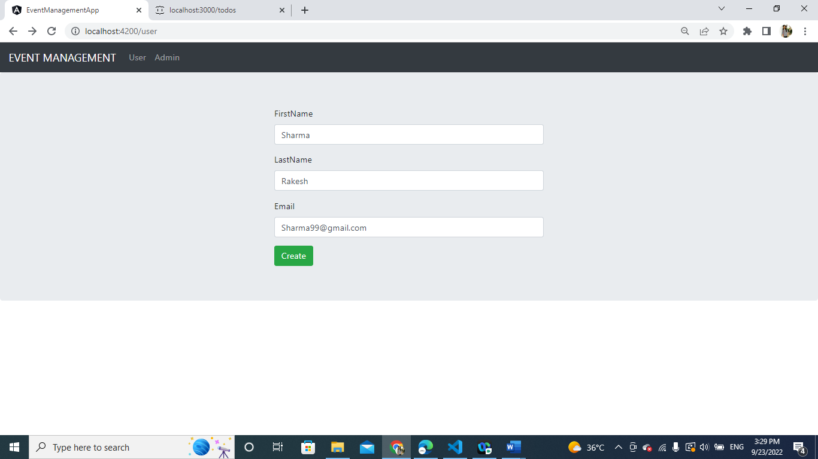

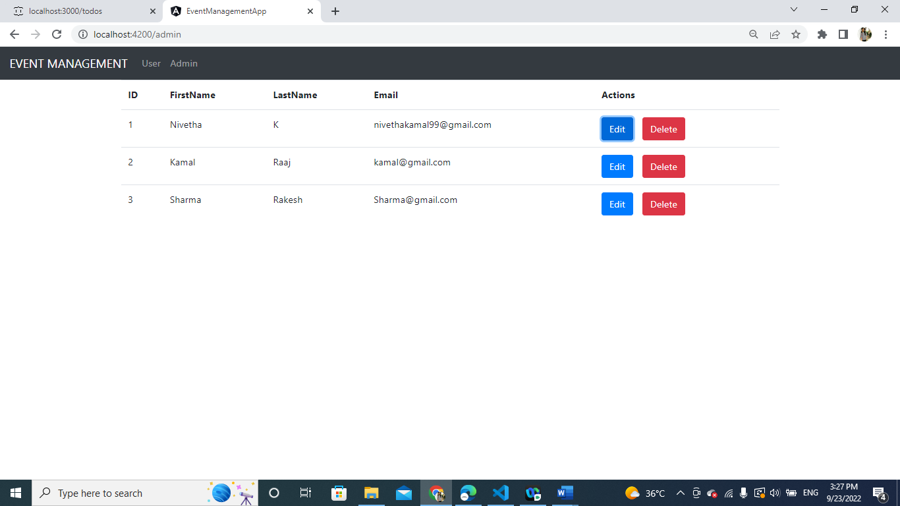

**UPDATING ID 1:**

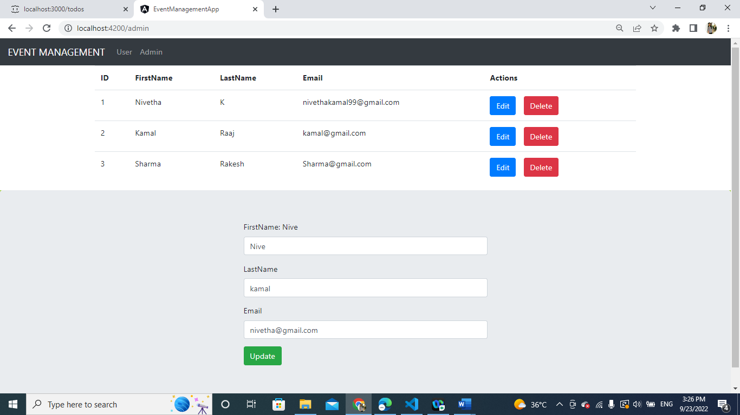

**DELETED ID NO 3:**

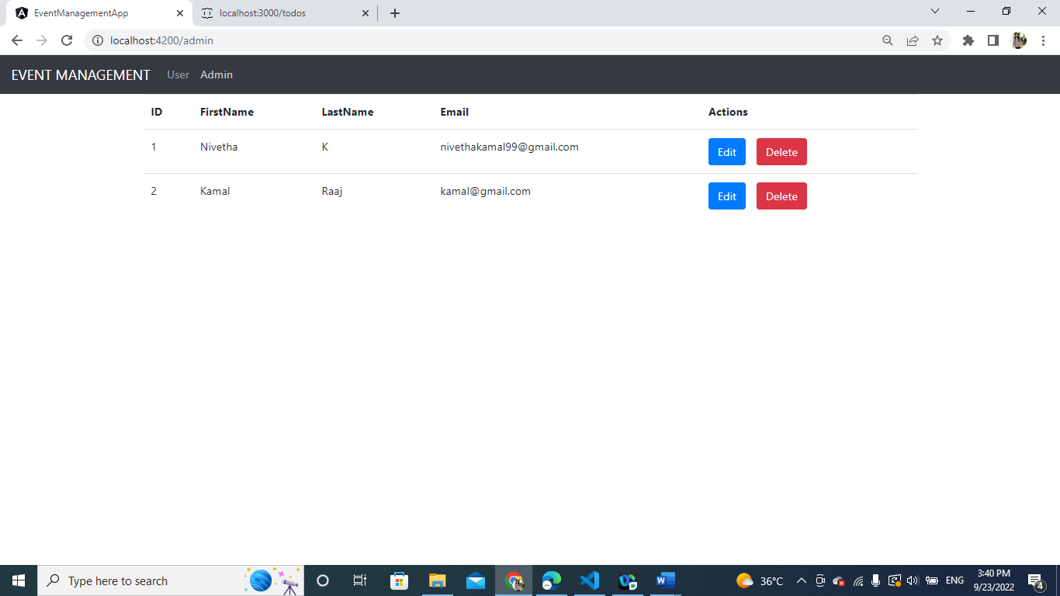

**Data.json**

